

Capstone Project – Phase B

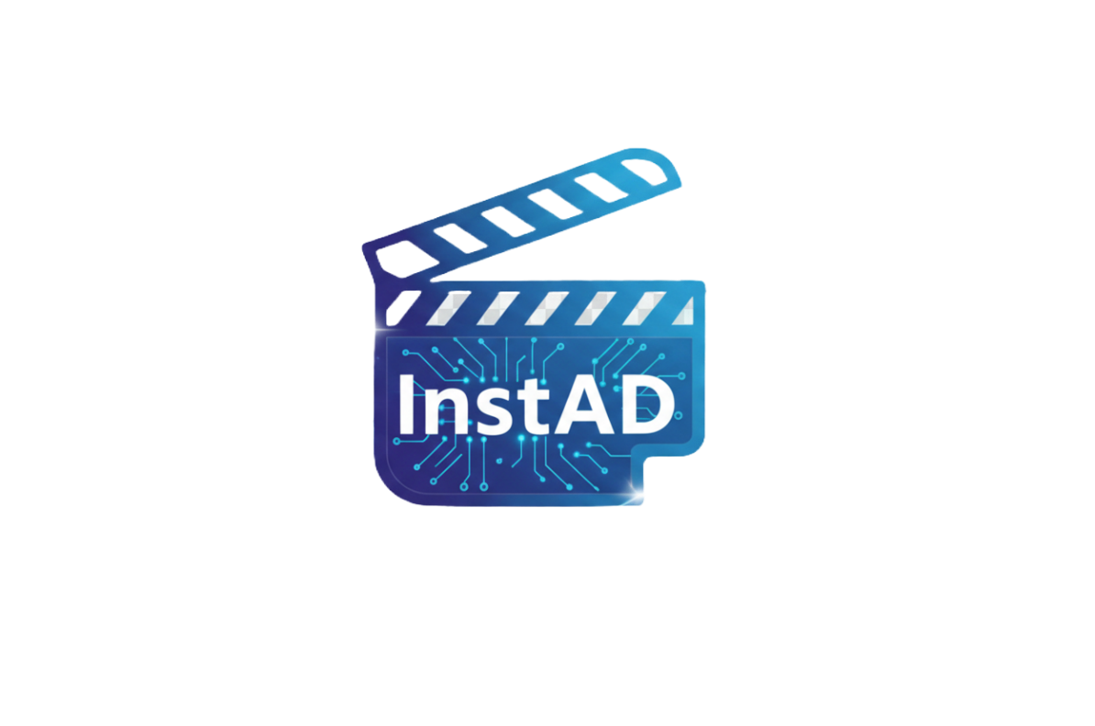

From Idea to AD in Moment

Daniel Ayash Maor Siboni
daniayash96@gmail.com awesomemaor@gmail.com

Supervisor:
Zakharia Frenkel
zfrenkel@braude.ac.il

InstaAD-Github

Table Of Contents
Abstract 3
1. Introduction & Background 3
1.1. The Problem: Challenges in Digital Advertising for SMEs 3
1.2. Literature Review: The Role of Generative AI 4
1.3. Existing Solutions and Their Limitations 4
1.4. The Need for an Accessible Solution 4
1.5. Proposed Solution: Our InstaAD Approach 4
2 Project Implementation & Achievements 5
2.1. General Description 5
2.2. The Solution: System Architecture & Operation 6
2.3. Core Algorithms & Workflow Logic 7
2.3.1. Adaptive Authentication & Zero-Downtime Migration 7
2.3.2. The "Adaptive Feedback Loop" Algorithm 8
2.3.3. The Generative Pipeline 8
2.3.4. Data Persistence & State Management 9
2.3.5. Asynchronous UI & Media Streaming 9
2.3.6. Quality Assurance (QA) & Testing Strategy 9
3. Engineering & Development Process 11
3.1. Development Methodology & Life Cycle 11
3.2. Technologies, Tools & Client Interaction 12
3.3. Engineering Challenges & Solutions 13
3.4. Results, Conclusions & Decision Making 14
3.5. Lessons Learned & Retrospective 15
3.6. Project Metrics & Success Criteria Evaluation 16
4. User Guide: Operating Instructions 17
5. Maintenance Guide: System Environment & Installation 19
5.1. System Environment (Prerequisites) 19
5.2. InstaAD Installation & Setup 19
5.3. Project Architecture & Directory Structure 21

Abstract
The digital advertising landscape is essential for Small and Medium-sized Enterprises (SMEs), yet producing high-quality video content remains a costly and skill-intensive endeavor. While Generative AI offers potential solutions, existing platforms often present a technical barrier, requiring complex prompt engineering and lacking automated personalization. To bridge this gap, we developed InstaAD, an intelligent desktop application designed to democratize video advertisement creation.
Operating on a client-server architecture, InstaAD functions as an automated AI orchestrator. It translates simple natural-language inputs from the user into highly optimized instructions, which are then processed by advanced language and video synthesis models. Our system innovation is continuous learning of user interactions, historical preferences, and saved profiles to dynamically personalize future content generation.
Furthermore, the system is engineered for high reliability and flawless user experience, intelligently managing complex computational tasks behind the scenes to ensure continuous availability. By abstracting all technical barriers into an intuitive, automated workflow, InstaAD empowers users with no prior design or technical experience to generate professional, tailored, and ready-to-publish video advertisements.

1. Introduction & Background

1.1. The Problem: Challenges in Digital Advertising for SMEs
The intersection of Artificial Intelligence (AI) and digital marketing has transformed how content is produced. However, a significant gap remains in accessibility. Small businesses and independent creators often lack the financial resources to hire professional marketing firms. Furthermore, traditional manual methods of ad creation are time-consuming and require specific design skills .
Although AI technologies like Large Language Models (LLMs) and Generative Adversarial Networks (GANs) exist, leveraging them effectively typically requires technical expertise. Users must often navigate complex interfaces or possess knowledge of specific prompting techniques to achieve desired results. This creates a "technical barrier" that prevents non-technical stakeholders from utilizing the full potential of Generative AI for their business growth .

1.2. Literature Review: The Role of Generative AI
Recent advancements in Generative AI have revolutionized digital marketing. Unlike traditional AI, which focuses on data analysis, Generative AI actively creates original content. Key technologies identified in our research include:
Large Language Models (LLMs): Models such as OpenAI's GPT and Google’s T5 are used to generate persuasive ad copy, slogans, and scripts by understanding user intent and marketing patterns .
Generative Adversarial Networks (GANs): These networks, consisting of a generator and a discriminator, are pivotal in creating realistic visual content, including product images and dynamic video elements .

1.3. Existing Solutions and Their Limitations
Several tools currently attempt to address the market need, such as AdCreative.ai and Predis.ai. These platforms utilize machine learning to generate ad variations based on user inputs. However, market analysis reveals distinct limitations in these existing solutions :
Rigidity: Many platforms rely on pre-defined templates that restrict creative freedom.
Complexity: Tools often require structured input and multiple configuration steps, which can be overwhelming for novices.
Lack of Personalization: Most tools treat every session as new, failing to learn from the user's past preferences or brand voice.

1.4. The Need for an Accessible Solution
The literature confirms a growing demand for tools that democratize ad creation. Small and Medium-sized Enterprises (SMEs) require a solution that balances the power of Generative AI with ease of use. A system that integrates NLP for simple prompting with advanced image and video synthesis—while maintaining user context—addresses the critical gap between professional agency output and DIY marketing tools.

1.5. Proposed Solution: Our InstaAD Approach
To address these limitations, our project proposes InstaAD, a streamlined desktop application focused on simplicity and automation. Unlike existing tools that require complex parameter tuning, InstaAD utilizes a natural language interface. The system leverages advanced API integration to orchestrate text and video generation in a single workflow. The goal is to provide a "one-click" experience where a non-technical user can input a simple idea (e.g., "A summer sale for a coffee shop") and receive a fully formed advertisement, complete with visual and textual elements.

2 Project Implementation & Achievements

2.1. General Description
System Goals and Nature InstaAD was developed with a single core objective: to democratize the creation of high-quality video advertisements. In the current market, producing a professional ad requires either expensive marketing agencies or complex technical skills in video editing and prompt engineering. The nature of our system is that of an "AI Orchestrator". It does not merely edit video; it generates it from scratch. The system abstracts away the complexity of interacting with advanced AI models (LLMs and GANs), providing a simplified "Text-to-Video" interface. The primary goals of the system are:
Accessibility: Eliminating the "technical barrier" by requiring only natural language input.
Automation: Delivering a fully finished video product (visuals + motion) without manual editing.
Personalization: Unlike static templates, the system learns from the user's history to refine future outputs.
Target Audience Based on our research, the system is tailored for three specific user groups:
- Small and Medium-Sized Enterprises (SMEs): Business owners who need to run campaigns but lack the budget for professional production.
- Independent Creators: Influencers needing a high volume of content without spending hours editing.
- Freelance Marketers: Professionals who need to rapidly prototype ad concepts for clients.
Implementation Strategy (High Level) To achieve these goals, InstaAD is implemented as a Desktop Application to provide a dedicated, distraction-free workspace.
Simplicity: The interface is designed with a "One-Click" philosophy. Complex parameters (aspect ratio, frame rate, seed) are handled automatically by the backend logic.
Adaptive Deployment: The backend is designed to run in a Docker container for stability. However, the system includes a smart Auto-Fallback Mechanism to ensure a "Plug-and-Play" experience on any machine.
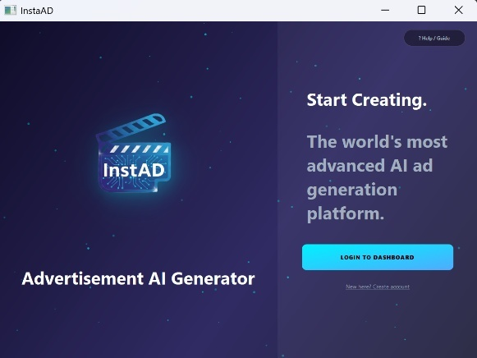

Figure 1: Welcome Screen of InstaAD

2.2. The Solution: System Architecture & Operation
System Architecture (Deployment & Package Level) The InstaAD system is built upon a modular Client-Server architecture, primarily containerized using Docker to ensure consistency across development and production environments.
The Client (Frontend Layer):
- Developed using Python and PyQt5.
- Acts as the presentation layer, handling all user interactions and communicating with the backend via RESTful HTTP requests.
The Server (Backend Layer):
- Built with FastAPI, running inside a lightweight Python 3.10 Docker container (instaad-backend).
- Exposes endpoints for Authentication, Ad Generation, and Status Polling.
Orchestrator: Acts as the central logic unit connecting the user, the database, and external AI services.
The Database (Data Layer):
- MongoDB serves as the persistence layer, running in a dedicated Docker container (instaad-mongo).
- Stores unstructured data such as User Profiles, Hashed Passwords, and Ad History logs.
Hybrid Server Orchestration Algorithm (Self-Healing) To ensure maximum usability in environments without Docker, the system implements a Failover Mechanism. Upon startup, the client executes a "Handshake Protocol" on port 8000.
- Path A (Docker): If the port is active, it connects to the isolated container environment.
- Path B (Local Fallback): If the port is closed (Docker is down), the application automatically spawns a background Daemon Thread that initializes a local uvicorn instance. This ensures the application works "out of the box" regardless of the host's Docker configuration.

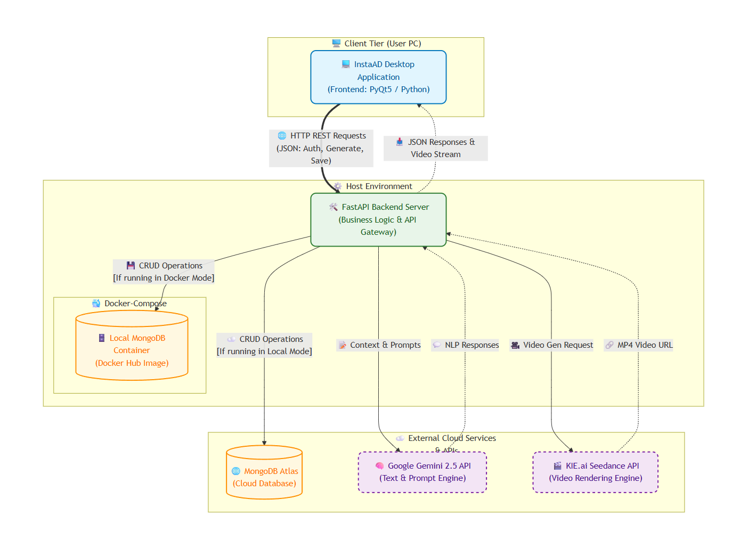
Figure 2:Architecture Diagram

2.3. Core Algorithms & Workflow Logic
To transition from a simple API wrapper to an intelligent platform, InstaAD relies on several advanced algorithmic processes.

2.3.1. Adaptive Authentication & Zero-Downtime Migration
User security is managed through a Cryptographic Hashing Algorithm. Passwords are never stored in plain text.
- Algorithm: We utilize Argon2 (via passlib), a memory-hard algorithm highly resistant to GPU brute-force attacks.
- Migration Logic: The system features a sophisticated protocol that upgrades legacy user data on the fly. When a user logs in, the system detects if the stored password uses the legacy format (Plain Text) or the modern format ($argon2 prefix). If legacy is found, it verifies the credentials, immediately hashes them with Argon2, and updates the database silently. This ensures seamless security upgrades without forcing a password reset.

2.3.2. The "Adaptive Feedback Loop" Algorithm
A core component of the system's personalization engine is its continuous learning mechanism. It implements a basic reinforcement learning cycle to improve ad quality over time based on user interactions.
Phase A: Data Collection (Keyword Extraction & Feedback): Every time a user generates an ad or provides direct feedback, the system updates their profile. Manual prompts are processed through an extraction algorithm that normalizes text, strips punctuation using Regex, and filters out common stop-words. To optimize database storage and ensure the AI model only processes the most relevant recent context, the system leverages MongoDB's $push operator combined with the $slice modifier. This strictly caps the user's searched_keywords array at the 50 most recent entries and the feedback_notes array at 25.
Phase B: Historical Analysis (Intent Enrichment): When a new ad is requested, a Query Algorithm fetches the user's historical context (the last 5 searched keywords and the last 3 feedback notes) from MongoDB. Frequency analysis identifies common patterns in the user's style.
Phase C: Context-Aware Prompt Generation: The system dynamically modifies the raw input (e.g., "Create an ad for shoes") by leveraging Google Gemini 2.5 Flash Lite. The raw text, combined with the extracted user history, is sent to Gemini, which acts as an expert "Prompt Engineer" to rewrite and optimize it into an enhanced algorithmic prompt, such as: "Create an ad for shoes. CONTEXT: This user prefers a Minimalist style and Upbeat music based on previous history.

2.3.3. The Generative Pipeline
The core value of InstaAD lies in its ability to orchestrate multiple AI services. This is not a simple linear process but an Asynchronous Pipeline.
Stage 1: Intent Analysis & Enrichment (NLP): As defined in the Feedback Loop, the system retrieves the user's historical context (Last 5 searched keywords + Last 3 feedback notes) and injects this data into the prompt to personalize the result.
Stage 2: Contextual Prompt Engineering Layer (Gemini): The enriched prompt is sent asynchronously to Google Gemini with a strict System Instruction to act as a "Video Prompt Engineer".
Resilience Pattern: The code includes a try-except fallback. If Gemini fails (API key missing or Quota exceeded), the system degrades gracefully and uses the manual prompt instead of crashing.
Stage 3: The system passes the optimized text from Gemini to the handle_generate function, which initiates the rendering process by calling create_seedance_video_task. This function dispatches the payload to the KIE API and retrieves a unique task_id, which is then routed to the frontend's AdPreviewScreen. Because video generation is a time-consuming asynchronous process, the preview screen triggers a polling mechanism that repeatedly queries the backend's /check-video-status endpoint. The backend, in turn, sends GET requests to the external KIE API to monitor the job's progress. Once the backend detects a SUCCESS status and retrieves the final video_url, the polling loop terminates, and the generated video is seamlessly streamed and played for the user via the embedded VLC player.
Example of a use prompt:
Using user prompt as base: make me an ad about soccer team playing game in the stadium
Then gemini enhanced the prompt: Epic aerial shot, golden hour, stadium roars, low angle close-up on a player's determined face, grass textures, dynamic movement, cinematic drama.
Link: InstaAD Soccer Advertisement Example
After user provided feedback:
make players with t-shirts, and yellow soccer ball:
Then gemini enhanced the prompt: Epic cinematic shot: low-angle, wide lens, stadium lights blaze on dynamic soccer players in t-shirts, a yellow ball arcs. Intense atmosphere, grass texture.
Link: InstaAD Soccer Advertisement Example After Feedback
Example of a Recommended Ad:
Clicked the "Recommended Ad" button (No text prompt provided).
Using default base prompt for recommended mode: Create a short, engaging, professional video advertisement suitable for social media platforms. Enriched prompt with searched keywords: ['soccer', 'team', 'playing', 'game', 'stadium'] Enriched prompt with feedback notes: ['make players with t-shirts, and yellow soccer ball.', 'make the ball come in to the net and add zoom out effects']
Then gemini enhanced the prompt: Dynamic low-angle shot: A yellow soccer ball arcs into a net, stadium lights glinting off its surface. Seamless zoom-out, cinematic finish.
Link: InstaAD Soccer Advertisement Example Recommended AD

2.3.4. Data Persistence & State Management
The system utilizes Document-Oriented Storage across two primary collections: customers (user preferences) and saved_ads (media history).
Insertion & Deduplication: When saving an ad (validated via Pydantic), the system executes a Deduplication Query (find_one) to prevent redundant storage. If unique, it appends a UTC timestamp (datetime.utcnow()) and inserts the document.
Atomic Array Updates: To update user preferences efficiently without loading full documents, the backend leverages MongoDB's atomic operators. $addToSet (with $each) ensures only unique keywords are added, while $push appends new feedback notes directly into the user's profile.
Deletion Logic: Strict identification is enforced by mapping string IDs to BSON ObjectIds before safely executing delete_one, ensuring precise removal of user history.

2.3.5. Asynchronous UI & Media Streaming
To ensure a "Smooth 60FPS" experience, the application decouples Logic from the UI.
Threading Model: Heavy operations (Login, Registration, AI Generation) are offloaded to QThread Workers (GenerateThread, LoginWorker), keeping the Main GUI Thread free for animations.
Chunked Data Stream: When previewing video, the client does not load the entire file into RAM. It iterates over the HTTP response in 1MB chunks (1024 * 1024 bytes) and writes them sequentially to a temporary file, preventing memory overflows.

2.3.6. Quality Assurance (QA) & Testing Strategy
The project maintains high reliability through a comprehensive pytest suite, specifically divided into Unit and Integration testing environments.
Centralized Fixtures (conftest.py): We utilize pytest.fixture to globally inject a FastAPI TestClient and mock MongoDB instances (mock_db, mock_saved_ads_db). This allows full HTTP routing tests without spinning up a live server or database.
Targeted Test Suites: We developed specific test files for every core module. For example, auth_unit_test.py strictly validates edge cases in user input (e.g., short passwords), while ad_integration_test.py verifies complex logic like the deduplication query that prevents saving the same video twice.
External API Mocking (Monkeypatching): To test the asynchronous video polling mechanism without waiting for actual rendering or consuming costly KIE.ai API tokens, we implemented a USE_MOCK environment flag and utilized monkeypatch to simulate both SUCCESS and FAILED HTTP responses from the external video engine.
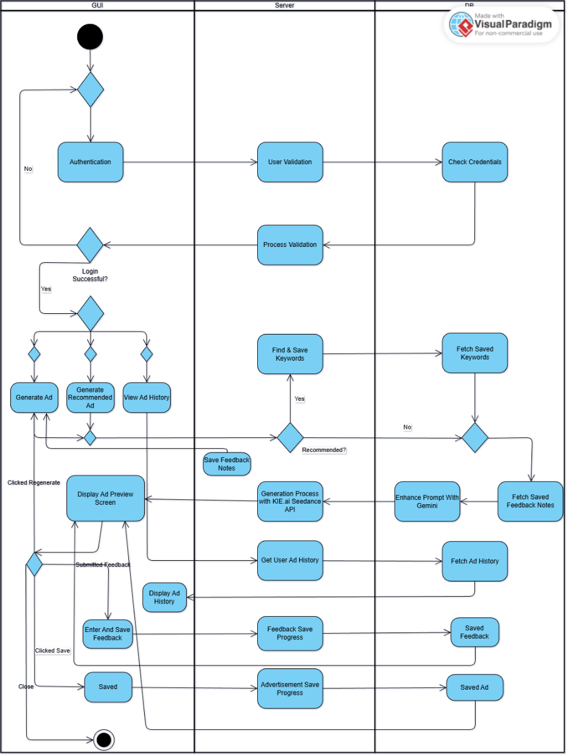
Benefit: This testing strategy ensures isolated, instant execution (milliseconds) that safely validates business logic without corrupting the production database or incurring third-party API costs.

Figure 3: Activity Diagram

3. Engineering & Development Process

3.1. Development Methodology & Life Cycle
The development of InstaAD followed an Iterative and Agile methodology. Because the project relied heavily on third-party AI APIs (Google Gemini and KIE.ai), we developed the system through continuous prototyping, testing, and refinement.
The research and development process was structured into five distinct phases:
Phase 1: Research & Proof of Concept: The project began with a feasibility study of Generative AI capabilities. We evaluated and tested various different AI APIs for both text and video generation to compare their quality, output generation time, and integration capabilities. After extensive research and trial, we selected Google Gemini 2.5 Flash Lite for context-aware prompt engineering and the KIE.ai (Seedance) API for video synthesis, proving that an automated text-to-video pipeline was technologically viable.
Phase 2: Backend & Database Engineering: We established the core logic layer using FastAPI and MongoDB. Moving beyond basic CRUD operations, we structured robust API routing with strict Pydantic data schemas and implemented advanced security measures, including Argon2 cryptographic hashing with a zero-downtime migration algorithm for legacy passwords. Furthermore, we engineered the database to support our "Adaptive Feedback Loop" by leveraging MongoDB's atomic operators ($push, $slice, $addToSet) to efficiently manage user context limits, and developed data deduplication queries to optimize storage when users save their generated media
Phase 3: Frontend Application & UX: Following the backend stabilization, we developed the PyQt5 desktop client with a strong emphasis on user experience. We designed a modern, visually appealing, and highly accessible interface, ensuring the workflow remains intuitive and straightforward for non-technical users. A major technical challenge in this phase was implementing multi-threading (QThread) to decouple heavy network requests from the main GUI, keeping the application fluid and responsive during the asynchronous video generation process. Furthermore, to provide a seamless in-app experience, we successfully embedded a native VLC media player directly into the PyQt5 application window, allowing users to stream and view their generated advertisements instantly without relying on external software
Phase 4: Orchestration & Containerization: To ensure cross-platform compatibility, we wrapped the backend and database in Docker containers. Simultaneously, we developed the Hybrid Server Orchestration (Self-Healing) algorithm, ensuring the application could gracefully fall back to a local process if Docker was unavailable.
Phase 5: QA, Optimization & Refinement: The final stage involved building the pytest suite with mocked API responses to validate the system's stability without incurring API costs. We also fine-tuned the "System Instructions" sent to Gemini to achieve the most accurate and cinematic video generation prompts.

3.2. Technologies, Tools & Client Interaction
Development Tools & Technologies
To build a robust, full-stack desktop application, we utilized a diverse set of modern development tools and libraries:
Programming & Frameworks: Python 3 (Core language), PyQt5 (Frontend GUI), and FastAPI (Backend REST architecture).
Database & Data Management: MongoDB (NoSQL document storage) for managing user profiles, prompt history, and media metadata.
AI & External APIs: Google Gemini 2.5 Flash Lite (for NLP and contextual prompt enrichment) and KIE.ai Seedance 1.5 Pro API (for AI video rendering).
DevOps & Architecture: Docker and Docker Compose for containerization, alongside Uvicorn to run and host our FastAPI backend server.
Testing & Security: pytest and unittest.mock for quality assurance and API simulation, and passlib (Argon2) for cryptographic password hashing.
Media Integration: python-vlc bindings for embedding a native video player directly within the PyQt window.
Version Control: Git and GitHub for source code management and collaborative development.
Client Interaction & Feedback Loop
In the context of this project, our "client" consisted of our academic supervisor and peers who simulated our target demographic of non-technical SME owners. Continuous interaction with them profoundly shaped the development process:
Milestone Reviews: We held regular review sessions with our supervisor to validate architectural decisions, such as the implementation of the Hybrid Server Fallback mechanism and the security protocols.
Usability Testing: We conducted hands-on testing sessions with peers. Observing their interaction with the software revealed that too many input parameters caused confusion.
UX Adjustments: Based on this direct client feedback, we pivoted our frontend design. We removed complex configuration menus (like aspect ratio or frame rate) and replaced them with our current "One-Click" interface, pushing all the complex parameter tuning to the backend AI orchestrator. We also added visual loading indicators to keep the user informed during the asynchronous video generation process.

3.3. Engineering Challenges & Solutions
During the development of InstaAD, we encountered several complex analytical and engineering challenges. Our problem-solving approach focused on optimizing system performance and user experience:
Challenge 1: Asynchronous Video Generation & UI Blocking
The Problem: Rendering video via the KIE.ai API is a heavy process. Initially, waiting for the HTTP response caused the PyQt5 graphical interface to freeze.
The Solution: We engineered a multi-threaded architecture using QThread in the frontend to handle network requests. On the backend, we developed an asynchronous polling algorithm (/check-video-status), allowing the main GUI to remain responsive while the video rendered.
Challenge 2: Managing Memory Limits & API Costs
The Problem: Saving all user history indefinitely would bloat MongoDB and eventually exceed the Gemini API token limit during context injection. Additionally, continuously calling the live KIE.ai video generation API during UI development and testing would rapidly exhaust our budget and API quota.
The Solution: We implemented two cost-saving mechanisms. To manage database memory and LLM limits, we created an "Adaptive Feedback Loop" using MongoDB's $push and $slice operators to maintain strictly the 50 most recent keywords and 25 feedback notes. For development testing, we introduced a MOCK environment flag. When active, the system bypasses the live rendering engine and returns a pre-generated video, allowing us to endlessly run tests and UI experiments without wasting real API tokens
Challenge 3: Cross-Platform Deployment & Dependency Issues
The Problem: Relying strictly on Docker meant the application would fail on host machines lacking a Docker daemon.
The Solution: We designed a "Hybrid Server Orchestration" mechanism. The client executes a startup handshake on port 8000; if it fails (indicating Docker is down), the system degrades gracefully by spawning a local thread to run the FastAPI server natively.
Challenge 4: Media Playback Integration (Frontend)
The Problem: PyQt5's native media player is outdated and struggled to reliably load and stream the modern video advertisements generated by our system.
The Solution: To ensure a smooth user experience, we bypassed the native component entirely and successfully embedded a VLC media player (python-vlc bindings) directly into the PyQt window, achieving high-quality playback.
Challenge 5: AI API Sourcing & Selection
The Problem: Finding a high-quality Generative AI video API that fit our specific programmatic requirements was exceptionally difficult.
The Solution: We conducted extensive market research and multiple Proof of Concept tests across various AI generation engines. We ultimately pinpointed and integrated the KIE.ai (Seedance 1.5 Pro) API, which provided the optimal balance of rendering quality and technical accessibility for our project.
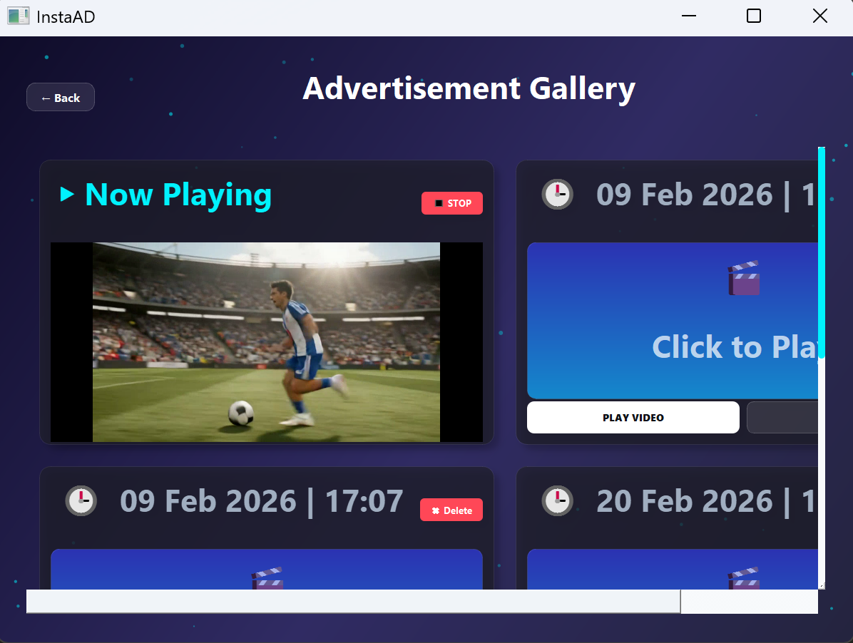

Figure 4: VLC embedded in the PYQT5 window application

3.4. Results, Conclusions & Decision Making
Goal Achievement & Conclusions The primary goal of InstaAD was to eliminate the technical barrier in video ad creation for SMEs, and we successfully achieved this. We built a fully functional desktop application that takes a simple natural language input and autonomously orchestrates complex AI models (Gemini for NLP and KIE.ai for video synthesis) to deliver a final video product. The main conclusion from our development process is that while integrating multiple asynchronous generative APIs is technically complex, abstracting this complexity from the end-user into a "One-Click" workflow is both possible and highly effective.
Coping with Challenges & Quality Assurance To ensure system stability and effectively handle bugs, we combined automated and manual testing. We implemented a Continuous Integration (CI) workflow that executed our pytest suite before every git push, preventing regressions. Additionally, we conducted functional usability testing with peers; their hands-on feedback allowed us to identify and resolve bugs that automated tests missed. When live API testing became too costly, we engineered a MOCK environment flag to safely simulate video generation.
Decision-Making Considerations Throughout the project, our technical decisions were consistently guided by the trade-off between performance, cost, and user experience:
Prompt Restrictions for Speed: Initially, Gemini's lengthy responses caused system delays. We refined our System Instructions to enforce a strict, minimal word count, which drastically reduced the LLM's processing time and API latency.
Polling & Chunk Streaming: To minimize perceived wait times during the heavy KIE.ai rendering process, we optimized the frequency of our asynchronous polling loop. Furthermore, the client streams the final video in 1MB chunks rather than waiting for a full file download, enabling near-instant playback.
Context Capping: We capped user history in MongoDB, Injecting unlimited data into Gemini would inflate token costs and increase response latency, making this limit a necessary trade-off for speed.
UI Simplicity: We deliberately hid complex AI parameters (e.g., seed values, frame rates) to maintain a fast, distraction-free workflow tailored for non-technical users.

3.5. Lessons Learned & Retrospective
Methodology & Decision Evaluation: Did we work correctly? Overall, our iterative engineering approach, combined with CI workflows and peer usability testing, proved highly effective. Crucially, we deliberately chose to build a Desktop Application (PyQt5) to challenge ourselves and expand our skill set beyond our existing web development knowledge. This forced us to successfully tackle complex concepts like OS-level multi-threading, native VLC media embedding, and local Docker fallback mechanisms. From an educational perspective, making this technically difficult choice was absolutely correct, as we successfully mastered these new domains.
What would we change in hindsight? Looking back at the development process, if we were to rebuild or upgrade the system, we would implement the following architectural improvements:
Structured API Evaluation Process: Early in the project, we spent excessive time conducting unstructured trial-and-error testing to find a suitable video generation API. Looking back, we should have established a strict, quantified evaluation matrix from day one—scoring potential APIs based on rendering latency, token cost, and documentation quality. This structured approach would have significantly shortened our research phase.
API Adapter Pattern: Successfully integrating complex APIs like KIE.ai and Google Gemini directly into our backend required significant effort and perfectly fulfilled our academic goals. However, this approach tightly couples our system to these specific providers. Especially for a commercial product we would implement the "Adapter Design Pattern". Creating a generic backend interface would allow us to swap AI engines in the future without rewriting core logic, preventing system failure if a provider changes its endpoint structure.
Cloud-Hosted Backend vs. Local Orchestration: We designed the system to run entirely locally using Docker and a Uvicorn fallback. In hindsight, hosting the FastAPI backend and MongoDB on a remote cloud would better align with industry standards. A cloud architecture enhances security (protecting AI API keys) and enables updates without requiring client patches. However, a local architecture was sufficient for this educational project, as our primary focus was building the software from scratch, investing in the core logic, and developing our engineering skills.

3.6. Project Metrics & Success Criteria Evaluation
Did we meet our project metrics? Yes, we successfully evaluated the final system against the exact expectations and Evaluation Matrix established at the beginning of the project. Our evaluation confirms we met our primary targets:
Metric 1: Generation Speed & Efficiency
Target: Generate complete advertisements in close to one minute from initial prompt to output.
Result: While most generations met this goal, high server loads on the external KIE.ai API occasionally extended rendering times to slightly over a minute. So, we optimized our Gemini prompts for faster NLP processing and reduced our asynchronous polling interval (to a minimal millisecond value), ensuring the UI fetches the video the exact moment it finishes rendering. Even with these slight third-party API delays, generating an ad in ~75 seconds remains vastly more efficient than manual video editing.
Metric 2: Usability & Accessibility
Target: The system must be accessible from any regular PC and allow users with basic technical knowledge to create full ads without external help or training. We aimed for a 90% User Satisfaction rate.
Result: The "One-Click" PyQt5 interface completely hides the complexities of prompt engineering. Coupled with our Hybrid Server mechanism (which allows the app to run on PCs without Docker), we successfully delivered a highly accessible solution that saves users the cost and time of making advertisements.
Metric 3: Output Quality, Relevance & Personalization
Target: Our evaluation matrix required 90% Ad Relevance, 90% NLP Processing Quality, and 85% Personalization Accuracy. The output needed to improve over time based on user history.
Result: The integration of Google Gemini successfully parses and tokenizes user intent. Our "Adaptive Feedback Loop" and Keyword extraction effectively injects the user's historical preferences (saved in MongoDB) into new prompts, ensuring the generated media is highly personalized and visually appealing without requiring complex instructions.
Metric 4: System Stability
Target: No critical crashes or bugs during regular use.
Result: Implementing multi-threading (QThread) prevented UI freezes during heavy asynchronous API requests. Combined with our strict CI testing workflow and Pydantic data validation, the application remains stable and fluid throughout the entire ad creation lifecycle.

4. User Guide: Operating Instructions
This section outlines the standard operational flow of the InstaAD desktop application. The guide focuses on the primary successful use cases, from initial registration to exporting your final video advertisements, in addition there is an help guide for the user in the application welcome screen.
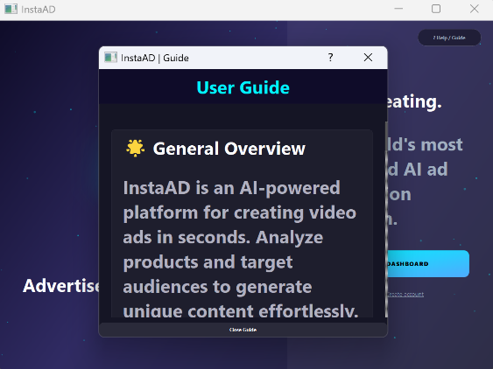
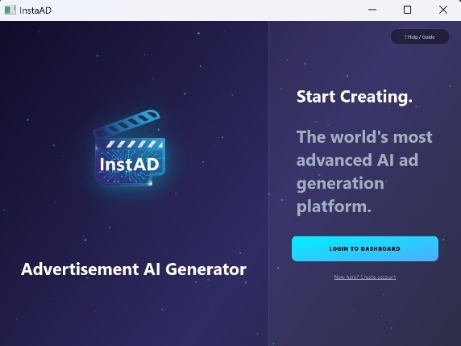

Figure 5: Welcome screen to user guide

Phase 1: Account Access (Registration & Login)
First-Time Users: Upon launching the application, click on the "Create an account" button. Fill in the required details to create your account.
(Your Password must be more than 4 characters long, and your Business Field must be more than 2 characters long.)
Returning Users: Enter your credentials on the welcome screen and click "Log In".
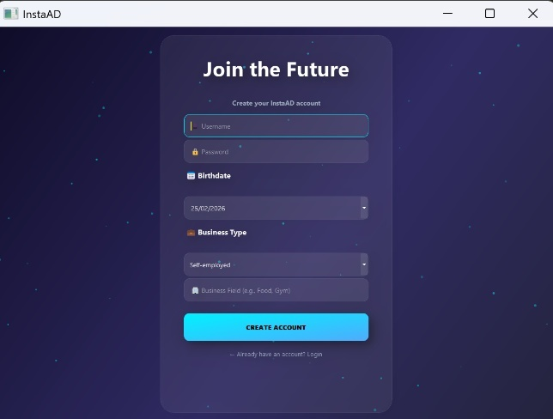
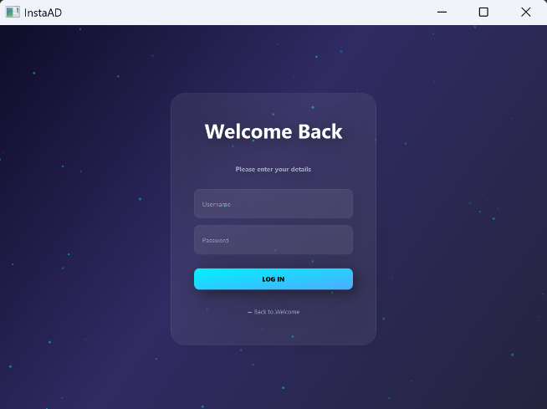

Figure 6: The authentication interface (Login & Registration)

Phase 2: The User Home Screen (Dashboard) Upon successful login or registration, you will be directed to the User Home Screen. This is your main control center. From here, you can choose between three primary actions by clicking their respective buttons:
- Start New Ad (Generate a new advertisement from scratch).
- Recommended Ad (Generate a personalized ad based on your profile).
- Ad History (Access your previously generated videos).
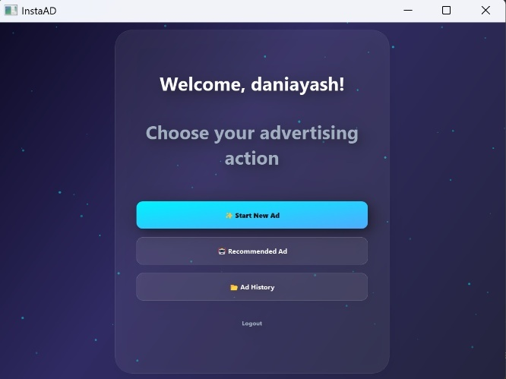

Figure 7: The main user dashboard

Phase 3: Creating a New Advertisement
Navigate to Generation: Select "Start New Ad" from the Home Screen to open the Generation Screen.
Entering your idea: Type a description of the advertisement you want to create in the main input box(The description must be at least 5 characters long).
Generating: Click the "Generate Ad" button. The system will display a loading screen and text while it renders your video.
Review & Save: Once completed, the video will play in the built-in media player. If you like the result, click the "Save to gallery" button to securely store it in your account.
Optional Feedback: Below the regenerate and save to gallery buttons, there is a "Submit Feedback" text box. You can type any notes or critiques here. The system simply saves this text in the background to learn your preferences for future sessions.
Regenerate (Try Again): If you are not satisfied with the video and want to start over, click the "Regenerate" button. This action simply returns you to the previous input screen, giving you the option to write a new prompt and create a fresh video.
Phase 4: Recommended Advertisement (Personalized Generation)
If you select "Recommended Ad" from the Home Screen, the system will use your established Business Field and historical preferences to automatically craft a new, highly relevant advertisement.
You do not need to write a description for this option; the system will autonomously generate a targeted video based on your saved profile preferences and history.
Phase 5: Viewing History & Exporting Videos
Access History: If you select "View Ad History" from the Home Screen, you will access a gallery of all the video advertisements you have previously generated and chosen to save.
Playback: Click on any past video in the list to play and watch in the media player.
Stop & Delete: On the right side of the video card there is a special dual-purpose button. While the video is actively playing, clicking this button will stop the playback. When the video is not playing, this same button transforms into a delete button. Clicking it in this state will permanently remove the video from your history.
Download: To save a video to your computer, click the "Download" button next to it. A standard file window will open, allowing you to easily save the .mp4 file directly to your PC for use on social media or marketing campaigns.
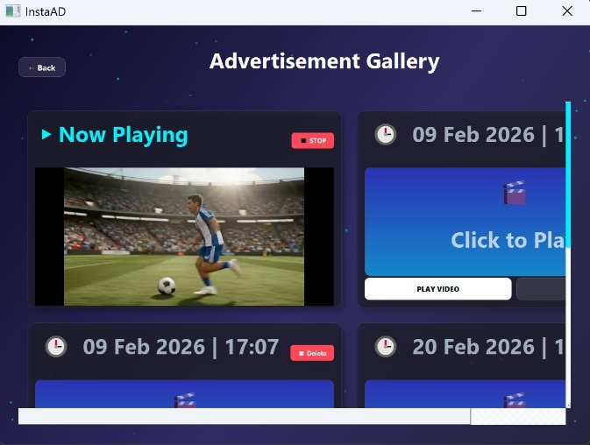
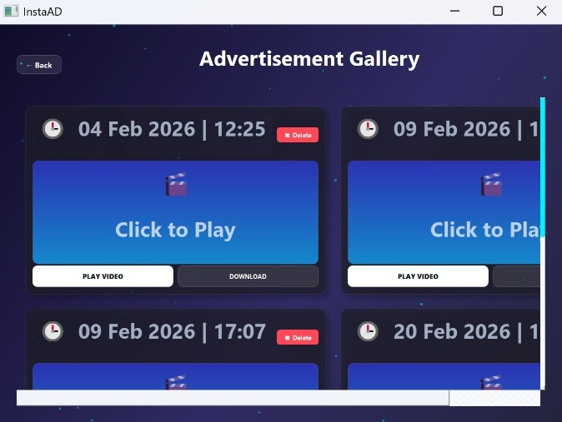

Figure 8: The user's personal ad history gallery

Phase 6: Securely Logging Out
When you have finished using InstaAD, you can securely log out of your account to protect your personalized data and history. Simply locate and click the "Log Out" button on the Home Screen (Dashboard). This action will safely end your current session and automatically return you to the initial Welcome/Login screen.

5. Maintenance Guide: System Environment & Installation

This section is intended for future developers or maintainers. It outlines the operating environment and provides step-by-step instructions for installing and running the custom InstaAD software.

5.1. System Environment (Prerequisites)
To run and maintain the InstaAD system, the following infrastructure must be present on the host machine (installation instructions for these standard infrastructures are omitted):
Hardware: A standard PC (Windows/Mac/Linux) with a stable internet connection for external API communication.
Software Infrastructure:
- Python (Version 3.10 or higher).
- MongoDB (Local instance or remote URI).
- Docker Desktop (Required only if deploying via Docker).
- API Keys: Active developer keys for Google Gemini and KIE.ai.

5.2. InstaAD Installation & Setup
The following steps detail how to initialize the dedicated software we developed.
Step 1: Obtain the Source Code First, pull the latest version of the project to your local machine:
Bash
git clone <https://github.com/awesomemaor/AI-Powered-Automatic-Advertisement-Generation-System.git>
cd InstaAD_generator

Step 2: The .env Configuration File (Mandatory) The system relies on a strictly separate, uncommitted file named .env located in the root directory. This file contains all the sensitive environment variables, including the external API keys and the password/connection URI for the MongoDB collection. Inside the ZIP archive we provided privately, there is a file named .env. You must extract this file and place it directly into the root directory of the cloned project (InstaAD_generator/). The system will not operate in terms of connections to APIs and the database without this file in the correct location.
Step 3: Choose Execution Method You can run the system using either a completely Local Server setup or via Docker. Choose one of the following methods:
Option A: Local Server Execution (Without Docker) This method runs the entire application directly on your local Python environment.
- Open your terminal in the project directory.
- Install the dedicated project dependencies:
Bash
pip install -r requirements.txt
- Run the application:
You can simply click the "Play" button in your IDE while in the main.py file or execute the following command in the terminal:
Bash
python Frontend/main.py

(Note: The system will detect that Docker is not running and will automatically spin up a local FastAPI server in the background before launching the GUI)
Option B: Docker Execution
This method isolates the backend services and the database using containerization. Thanks to our CI/CD pipeline, you do not need to build the backend locally. The latest stable version is always pulled directly from our Docker Hub repo in the cloud.
- Prerequisite: Ensure Docker Desktop is open and running on your machine.
- Open your terminal in the project's root directory and pull the latest images from our Docker Hub registry::
Bash
docker compose pull

- Start the backend server and database in "detached" mode (this frees up your terminal):
Bash
docker compose up -d
Understanding the CI/CD & Pull Process: When you execute the commands above, Docker Compose automatically orchestrates two distinct containers:
MongoDB Container: It pulls a pre-existing, official MongoDB image directly from Docker Hub.
FastAPI Backend Container: Instead of building an image locally, it pulls our pre-built, production-ready image directly from our cloud registry. This image was automatically built, tested, and pushed by our GitHub Actions CI/CD pipeline. This eliminates the need for manual environment configuration and significantly reduces local setup time.
- Once the Docker containers are successfully running in the background, you can launch the PyQt5 client application (Frontend) from your freed terminal:
Bash
python Frontend/main.py

5.3. Project Architecture & Directory Structure
To help future maintainers navigate the codebase efficiently, below is the complete directory tree of the InstaAD repository. The project follows a strict separation of concerns, dividing the client-side GUI, the server-side logic, and the testing suites.

InstaAD_generator/
├── .gitignore # Specifies intentionally untracked files to ignore (e.g., .env)
├── Backend/ # Server-side logic and API management
│ ├── endpoints/ # FastAPI route definitions and HTTP request handlers
│ │ ├── auth_login.py
│ │ ├── auth_register.py
│ │ ├── db_init.py # MongoDB connection initialization
│ │ ├── generate_ad.py
│ │ ├── save_ad.py
│ │ └── video_status.py
│ └── logic/ # Core business logic and external API integrations
│ ├── gemini_helper.py # Communication logic with Google Gemini API
│ ├── generate_ad_logic.py # Handles the video generation pipeline (KIE.ai)
│ ├── login_logic.py
│ ├── register_logic.py
│ └── save_ad_logic.py
├── Dockerfile # Build instructions for the Backend Docker container
├── Frontend/ # PyQt5 desktop application (Client-side)
│ ├── guis/ # User interface screens and visual components
│ │ ├── ad_history_screen.py
│ │ ├── ad_preview_screen.py
│ │ ├── generate_screen.py
│ │ ├── login_screen.py
│ │ ├── register_screen.py
│ │ ├── userHome_screen.py
│ │ └── welcome_screen.py
│ └── main.py # Main execution file for launching the Desktop GUI
├── backend_requirements.txt # Python dependencies required for the backend environment
├── docker-compose.yml # Orchestrates the backend and MongoDB containers setup
├── server.py # Main execution file for the FastAPI server (Uvicorn)
├── tests/ # Comprehensive automated testing suite
│ ├── conftest.py # Shared fixtures and configurations for Pytest
│ ├── integration/ # Tests component interactions and API flows
│ │ ├── ad_integration_test.py
│ │ ├── api_integration_test.py
│ │ ├── auth_integration_test.py
│ │ ├── feedback_integration_test.py
│ │ └── keywords_integration_test.py
│ └── unit/ # Isolated tests for individual functions and logic classes
│ ├── ad_unit_test.py
│ ├── auth_backend_unit_test.py
│ ├── auth_unit_test.py
│ ├── feedback_unit_test.py
│ └── keywords_unit_test.py
├── utils/ # Shared utility functions
│ └── security.py # Password hashing, encryption, and validation tools
└── README.md # General project documentation and overview

Architecture Summary:
- server.py & Backend/: The backbone of the system. Maintainers looking to update database schemas, add new API routes, or tweak the AI prompts should focus here.
- Frontend/main.py & Frontend/guis/: The client application. UI/UX updates, new buttons, or user flow changes are handled in these files.
- utils/security.py: The core of user data protection. This module manages sensitive operations such as password hashing, encryption, and input validation. Any changes to authentication protocols must be carefully implemented here.
- Dockerfile & docker-compose.yml: The deployment and containerization infrastructure. Modifying these files is necessary when changing the system's external dependencies, updating the Python environment, or altering how the backend orchestrates with the MongoDB container.
- tests/: Any changes made to the logic, UI, or security modules must be thoroughly verified against this test suite to prevent regressions and ensure system stability.

